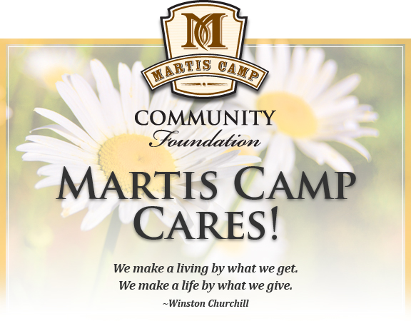

I would like to contribute to the MCCF.
Please add the amount below to my next monthly bill.

$________Monthly donation (please specify the amount)
________$500 one-time donation
________$1,000 one-time donation
________$2,000 one-time donation
$________Other amount, one-time donation (please specify the amount)
Member Number:________
Name to record/recognize the gift:

______________________________________________

Thank you for your donation!

The MCCF is a registered 501(c)(3) non-profit corporation.
Please return this form by email, post or in person to the concierge desk at the Camp Lodge.
Martis Camp Community Foundation email: mccf@martiscamp.com
Martis Camp • Attention: MCCF • 7951 Fleur du Lac Drive • Truckee, CA 96161

